Petes Platform

***Table of Contents***

Input Electronics 1

Integrating Dodo in to the pit 2

ATX Power Supply 3

GPS Setup 4

Installing and Managing FSX 5

LOMAC Multiplayer 8

ICP Pinout 9

PHCC 9

USB-Serial 9

PHCC Pinouts 9

PHCC Ports Addresses 10

Platform Start-up checklist 11

Build History 12

Todos 12

# Input Electronics

Gammatron with 64 expansion port.

Due to the large number of inputs (150+) that the Gammatron provides PPJoy is needed to virtualise the Gammatron. If this is not done then FSUIPC and other DX games won’t recognise the higher numbered inputs.

Need both ppjoy and joymapper.

PPJoy from Deon van der Westhuysen

Currently have the 64bit enabled version 8.4.5

<http://rs118cg.rapidshare.com/files/303690305/164291/PPJoySetup-0.8.4.5-early-release.exe>

JoyMapper from lightning JoyMapper_v0_4_1_0__x86_Setup.zip

<https://brightshadow.assembla.com/wiki/show/lightningstools>

# Integrating Dodo in to the pit

Struggled with getting Dodo to match up with FSUIPC command options available. The commands match up well with Key Commands available, but what this does me, that if the PC is rebuilt the commands will have to be manually re-entered as opposed to simply copying a FSUIPC file.

Current thought is assign unused stroked to the commands and then have FSUIPC match Joystick inputs and send keystrokes as required. Unfortunately it looks like a number of the actions are toggle only, so switches will need to be correctly positioned before launching Dodo. Because of this it is best to make the commands aircraft specific, and probably unique to the platform.

**Function FSX Key Binding**

|  |  |  |  |
| --- | --- | --- | --- |
| Switch | Start-up  Position | Recommended Function | Used Function (1st parameter to top |
|  |  |  |  |
| Engine Starter |  | Button Starter 1 (on/off) | Toggle starter 1 (repeat) |
| Idle Release Latch |  | Smoke system (on/off) | Toggle smoke system |
| Aft Fuel Pump Circuit Breaker | Out | Concorde nose visor (increase angle) | Increase concorde node visor |
| Fore fuel Pump Circuit Breaker | Out | Concorde nose visor (decrease angle) | Decrease concorde nose visor |
| Master Battery | Off | Master battery (on/off) | Offset Byte x281C 0/1 |
| Generator Switch | Off | Generator/Alternator (on/off) | Toggle Master Alternator |
| Generator Field Circuit Breaker | In | APU/Generator (toggle) | APU generator switch toggle |
| Generator Reset Circuit Breaker | In | APU (off) |  |
| Avionics Switch | Off | Avionics (on/off) | Offset setbyte x2E80 1/0 |
| Anti-Collision Lights | Off | Switch Strobe Lights (on/off) | Strobes On/Off |
| Position Lights Switch | Off | APU Start | Offset setbit x0D0C 1, clearbit 1 |
| Instrument Lights Switch | N/A | Panel lights (on/off) |  |
| Pitot Heat Switch | Off | Pitot heat (on/off) | Offset setbyte x029C 1/0 |
| Fuel Valve | Up | Engine 1 fuel valves (open/close) | Offset setbyte x3590 1/0 |
| Hydraulics Switch | Down | Concorde nose & visor (retract) | Decrease concorde nose visor fully |
| Caution Lights Bright/Dim |  | Concorde nose & visor (extend) |  |
| Anti-Ice Switch | Off | Carb heat/eng anti-ice (on/off) | Offset setbyte x08B2 1/0 |
| GPS / Nav Switch | Down | Nav 1/GPS (toggle) | Offset setbyte x132C 0/1 |
| Dir / Gyro Switch | Off | Cowl flaps (close incrementally) |  |
| Warning Mute Button | N/A | Tail wheel (lock/unlock) | Toggle Tailwheel lock |
| Over-Temp Test Button | N/A | Ballast valve (open/close) |  |
| Annunciator Test Button | N/A | Tail hook (up / down) | Toggle Tail hook handle |
| HTR Rotary Spoilers (arm) | Position 2 | Spoilers (extend/retract) |  |
| Increase difficulty | Position 2 |  | Spoilers Toggle |
| Decrease difficulty | Position 2 |  | Spoilers arm toggle |
| Caution LT (Annunciator) Circuit Breaker |  | Master Ignition (on) |  |
| Idle release | N/A |  | Toggle Smoke System |
| Lading lights forward | N/A |  | Landing lights toggle |
| Landing lights backward | N/A |  | Landing lights off |
| Increase Gov[1] | N/A |  | Increase Heli Gov Beep |
| Force Release (cyclic trim ) | N/A | Aileron trim (center) |  |

# ATX Power Supply

***What kind of Power Supply is needed? Can I use an ATX Power Supply?***       The Central Control Unit is powered by a standard 200 Watt PC AT Power Supply through a disk drive connector. These power supplies are available around the corner. The Central Control Unit on its turn powers the servos through the flat cable. The newer ATX Power Supplies do not switch on automatically when used stand-alone. These Power Supplies are switched on by the PC Mother board normally. In order to switch on such a power supply when used stand-alone, the green wire in the middle of the mother board connector has to be connected to ground (closest black wire).

# GPS Setup

The GPS takes a serial NEMA data feed.

System Setup

Communications Port

Baud Rate 19200

NEMA Input

NEMA GPS Input

Configure NEMA

GLL, RMC and RMB, GGA, GSA and GSV, APB

Software version 1.7.0

Cable Pinout

DB9

|  |  |  |  |
| --- | --- | --- | --- |
| DB9 |  |  | Lowrance |
| 1 | Gnd | Black | 3 |
| 2 |  |  |  |
| 3 | RX RS-232 | Green | 2 |
| N/C |  | White | N/C |
| N/C | +12V | Red | 1 |

[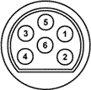](http://www.allpinouts.org/index.php/File:Conn_lowrance_002.gif)  
Pin connector as seen from back of Airmap 2000C

|  |  |  |
| --- | --- | --- |
| **Pin** | **Name** | **Description** |
| 1 | VCC | Power |
| 2 | RX | RS-232 (receive serial) |
| 3 | GND | Ground |
| 4 | TX | NMEA/Pseudo RS-232 (transmit serial) |
| 5 | - | DO NOT USE (recharging purposes) |
| 6 | - | DO NOT USE (recharging purposes) |

Was unable to buy an original NEMA cable, so had to modify a power only cable.

Modifying a power cable to a NEMA cable

1. Purchased a DB25 headshell with pins to be placed.
2. Drill out pin 2 of existing existing power connector with a 1mm drill all of the way through to the back for the cable.
3. Drill out pin 2 with a 3mm drill only partially so that the pin is able to seat in the socket without being able to be pushed all the way through
4. Heat Glue DB25 socket connector in Lowrance connector.

GPS Installation

Initially tried USB to serial converter with lead, but drivers not detected. Use Headshell USB to serial converter, worked fine.

USB to Serial converter is COM4

LUA Export

Export.lua

Lomac2Pit

UDP Rx

Write to Shared Mem

Lomac 2 GPS

Read shared mem output to Com Port

The shared memory file name is PTLomacSharedMemoryArea”

# Installing and Managing FSX

FSX

FSUIPC

FTX

FTX has been working on a major refresh Service Pack 3.

As of 15 November 2009

Dot NET 3.5 ***dotnetfx35.exe***

The following Airports are not yet SP3, so install them first

Install Avalon SP2 DVD

Install Coffs Harbour

Install SP3

Install AU SP3.001

Voz 3.0

Ants Complete Collection and Ants Boonah

Holgermesh100_SP3

Lastly Install Orbx Libraries 091028

C:\Downloads>dir d:

Volume in drive D is 091115_2050

Volume Serial Number is 5114-1C5B

Directory of D:\

15/11/2009 05:05 PM 1,436,953,674 OrbxFTXAUYSTW.zip

1 File(s) 1,436,953,674 bytes

0 Dir(s) 0 bytes free

C:\Downloads>dir d:

Volume in drive D is 091115_2024

Volume Serial Number is 3F0E-DB35

Directory of D:\

|  |  |  |
| --- | --- | --- |
| 16/12/2008 10:50 PM | 40,055,012 | ADF_AI_FS9.zip |
| 04/05/2009 09:47 AM | 23,916,264 | B206_VH-ORB100.zip |
| 24/10/2009 09:18 PM | 21,204,039 | dh83qanx.zip |
| 16/08/2008 08:24 AM | 35,113,704 | directx_9c_redist.exe |
| 26/09/2009 09:19 AM | 41,304,576 | Dodosim_206_FSX.msi |
| 26/01/2009 10:11 AM | 206,692,864 | dotnetfx35.exe |
| 05/05/2009 10:30 PM | 13,427,648 | f111494.zip |
| 05/05/2009 10:32 PM | 15,987,628 | f1119766.zip |
| 19/05/2009 11:40 AM | 40,743,358 | Flight Simulator X Files.zip |
| 22/03/2009 08:21 AM | 210,408 | FlightSimulator2004ACenturyOfFlightv1.0NoCD.rar |
| 26/01/2009 06:35 PM | 218,123,672 | fsx_sp1_ENU.exe |
| 26/01/2009 05:57 PM | 174,091,264 | fsx_sp2_ENU.msi |
| 15/11/2009 05:33 PM | 253,039,264 | FTXAUHOLGERMESH100_SP3.zip |
| 20/09/2009 09:21 AM | 361,777,326 | FTXAUSP3.001.zip |
| 20/09/2009 10:00 AM | 362,712 | FTXAUSP3.001b.zip |
| 20/09/2009 11:49 AM | 3,176,784 | FTXAUTRAFFIC210_UPDATE.zip |
| 15/11/2009 05:55 PM | 121,174,282 | FTXAUYBLN150_SP3.zip |
| 15/11/2009 06:13 PM | 167,888,853 | FTXAUYCUN150_SP3.zip |
| 04/05/2009 10:03 AM | 127,916,870 | FTXAUYMLT200.zip |
| 15/11/2009 07:23 PM | 113,852,486 | FTXAUYMLT_250_SP3.zip |
| 15/11/2009 07:26 PM | 26,489,790 | FTXAUYPLC150_SP3.zip |
| 15/11/2009 05:39 PM | 53,010,815 | FTXAUYPMQ200_SP3.zip |
| 15/11/2009 05:06 PM | 6,183,128 | FTXAUYRED300_SP3.zip |
| 15/11/2009 07:28 PM | 20,680,562 | FTXORBXLIBS_091028.zip |
| 11/01/2009 10:04 AM | 2,800,798 | G-Step Control V6.0.3 Full Install.zip |
| 14/05/2009 07:20 AM | 2,539,576 | gapanel_installer.zip |
| 03/11/2009 10:43 PM | 167,701 | GFdisplay.zip |
| 24/05/2009 12:26 PM | 5,470 | ItsYourPlane.application |
| 25/10/2009 10:23 PM | 699,427 | Lua_Plugins.zip |
| 29/07/2008 08:55 PM | 24,891 | MakeRwys.zip |
| 06/05/2009 10:26 PM | 143,960 | NZ_FSX.zip |
| 15/11/2009 07:11 PM | 532,676,383 | OrbxFTXAUYCNK.zip |
| 15/11/2009 12:11 PM | 501,114,992 | OrbxFTXAUYHBA.zip |
| 04/05/2009 11:05 AM | 456,236,147 | OrbxFTXAUYMMLSP1.zip |
| 15/11/2009 09:38 AM | 503,071,434 | OrbxFTXAUYWVA120_SP3.zip |
| 04/05/2009 10:04 AM | 1,417,920 | ORBXFTXEXTRA300S.zip |
| 19/05/2009 10:58 PM | 93,524 | OZX2.2_ORBX_Ant_Fields.zip |
| 15/10/2009 10:17 PM | 91,851,735 | Ozx_BELL_HD_Redux_RC2.zip |
| 01/12/2008 10:46 PM | 17,551,316 | RAAF AI v1.1.zip |
| 26/09/2009 02:54 PM | 32,098,802 | Sol7-HomeSim-1.0-b11-setup.exe |
| 24/05/2009 12:26 PM | 71,275,856 | SpeechSDK51.exe |
| 15/11/2009 07:41 PM | 26,739,121 | YMAV_AIRSHOW_2009(1).zip |

42 File(s) 4,326,932,362 bytes

0 Dir(s) 0 bytes free

C:\Downloads>dir d:

Volume in drive D is 091115_1155

Volume Serial Number is 600B-216A

Directory of D:\

21/10/2009 11:46 PM 2,291,563,138 OZx_AUS_v3.0.zip

1 File(s) 2,291,563,138 bytes

0 Dir(s) 0 bytes free

C:\Downloads>dir d:

Volume in drive D is 091115_1432

Volume Serial Number is 430A-00F9

Directory of D:\

|  |  |  |
| --- | --- | --- |
| 03/05/2009 07:26 PM | 535,686 | RealEnvironmentXtreme.exe |
| 15/11/2009 11:54 AM | 98,728,768 | REX20_Update.exe |
| 03/05/2009 07:25 PM | 472,178 | REXDownloader.exe |
| 04/05/2009 12:09 AM | 680,525,824 | rex_r1.dat |
| 04/05/2009 12:38 AM | 681,574,400 | rex_r2.dat |
| 04/05/2009 12:16 AM | 681,574,400 | rex_r3.dat |
| 04/05/2009 01:50 AM | 681,574,400 | rex_r4.dat |
| 03/05/2009 11:14 PM | 681,574,400 | rex_r5.dat |
| 04/05/2009 03:03 AM | 681,574,400 | rex_r6.dat |
| 03/05/2009 10:28 PM | 250,950,255 | rex_r7.dat |

10 File(s) 4,439,084,711 bytes

0 Dir(s) 0 bytes free

C:\Downloads>

# TRCSDK

Had to change temp variable to c:\ to get it to install

# Changing Physical Configuration for LOMAC

Remove Collective

1. The first three nuts and bolts remove easily
2. The last one requires the Black switch box to be relocated
3. Unscrew the unit (not the bracket) using the two screws holding the module
4. Recommend using alternate directions for nuts and bolts.

# LOMAC Multiplayer

LOVP (LOVP_v13p.zip) and Touchbuddy on all three pits.

Teamspeak3 on Dell server.

LOMAC2PIT.EXE 8082

LOMAC2GPS SharedMem

Platform All applications on single computer 10.

StartLomac.bat

F16 All applications on single computer

Foxy4.0 using lomac_nico.tmj - modified view centre. There is a jpg with mapping on it.

StartLomac.bat

General Pit TouchBuddy and LOMAC - Primary Computer

Foxy4.0 using lomac_nico.tmj - modified view centre

StartMPLomac.bat

Tacview094Setup.exe

LOMAC2PIT, LOMAC2GPS, and LOVP (TCP 8081) - Mid Computer

StartMPLomac.bat

TeamSpeak3 Dell

Teamspeak3Server.exe (need to connect to the Internet to start the server)

Currently missing dualstack com port. IP address to send TRCLink

# ICP Pinout

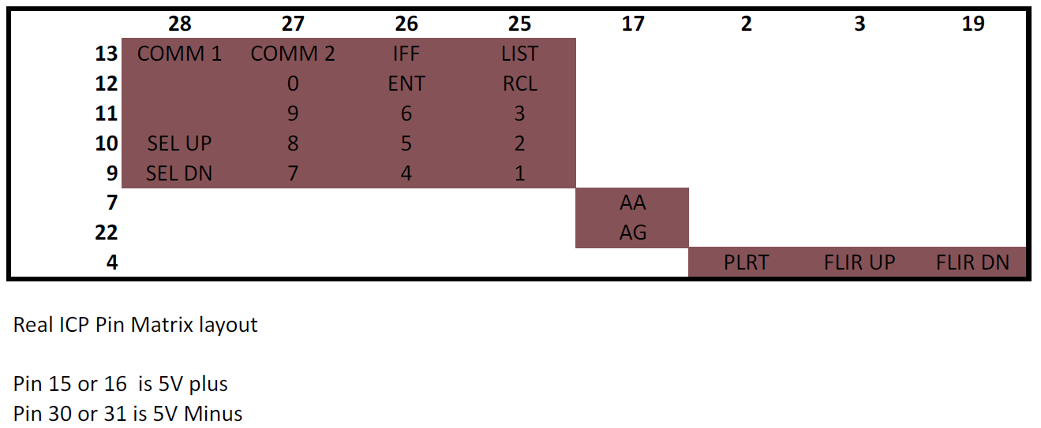

# PHCC

## USB-Serial

The CDROM supplied with the adaptor does not contain traditional inf files, need to execute PL-2303 Driver Installer.exe to install.

It installed to COM21 on the laptop.

In normal mode the board uses 115200,8,1,N for communications. The Red and Green LEDs in the middle of the board flash alternately which receiving data. If the Space bar is pressed the board returns ‘PHCC-0.1.8’

Lightnings test tool can be used to check the PHCC. On my laptop is automatically discovred the correct COM port.

## PHCC Pinouts

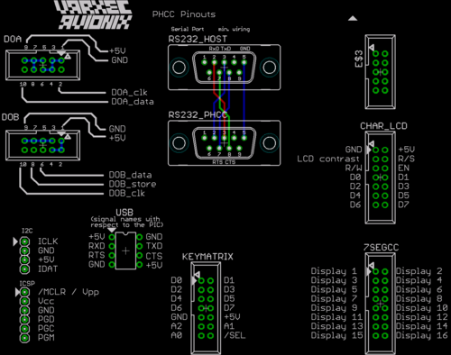

Buses on Motherboard

DOA (Digital Out Type A) - unidirectional, uses Addressable PIC to PIC Protocol (AP2PP). This supports up to 256 daughter boards.

DOB (Digital Out Type B) - unidirectional, daisy chained shift register bus. Similar to SPI.

Key 64D Pinout

## PHCC Ports Addresses

Following addresses are used within the DOA boards that I have run:  
  
DOA_Stepper: 0x73, 0x72, 0x71, 0x70  
DOA_Aircore : 0x83, 0x82, 0x81, 0x80  
DOA_Servo : 0x2C, 0x2B, 0x2A  
DOA_AnOut : 0x23, 0x22, 0x21, 0x20  
DOA_40DO : 0x13, 0x12, 0x11, 0x10  
DOA_7seg : 0x34, 0x33, 0x32, 0x31, 0x30

# Platform Start-up checklist

1. Raise Projector Screen.
2. Check underneath for any cables that may have come lose.
3. Check underneath for higher items that me be crushed
4. Ensure that Right Hand seat is not all the way back
5. Platform disable switch set to centre position
6. Remove central LCD protector (temporarily remove Yoke clamp and slide out)
7. Power up Primary PC and Projector
8. Start CKAS Driver
9. Launch Application
10. Once Application is running and CKAS driver has sensed application power up platform. The platform will jump to position so stand clear.

PC Start-up checklist

1. Start Joymapper, load PC-Platform config file and run (can be automated)
2. Start Motion Platform Driver
3. Launch Application

# Build History

12/3/10 First full Dodo startup, using only FSUIPC settings, no customer key mappings needed.

14/3/10 Mounted LH Touch screen

14/3/10 Found was losing Saitek Panel randomly. Move to use 4th USB port now stable.

# Todos

Locate USB hub for mouse and keyboard on back LHS

Install Hughes 500 add-on

Install PCI Video card

Install Sound card

Install and configure sound card for Radio chatter

Develop start-up switch position template

Replace stacked Video lead with a single lead

Move monitor to 12V power source at top

1. Extend exiting 12V lead
2. Look at 12V distribution options

Paint Timber

Check 19 inch monitor for possible RHS installation.

Need to modify GPS Driver to use COM4

Configured FSUIPC GPS Out and save

Ger LUA file for GPS out and other and install/configured LUA receiver.

Modify GPS out to only open comport on program start-up and shutdown, and automatically determine platform or static and open appropriate comport.

1. Increase Gov does not change switch position in VC. Only efftective when turbine in green region.